**Terna Engineering College**

**Computer Engineering Department**

Program: Sem VII

[**Course: Big Data Analytics & Computational Lab -I (BDA&CL-I)**](https://github.com/Amey-Thakur/BIG-DATA-ANALYTICS-AND-COMPUTATIONAL-LAB-I)

**Experiment No. 06**

**PART B**

**(PART B: TO BE COMPLETED BY STUDENTS)**

***(Students must submit the soft copy as per the following segments within two hours of the practical. The soft copy must be uploaded on the Blackboard or emailed to the concerned lab in charge faculties at the end of the practical in case there is no Blackboard access available)***

| Roll No. 50 | Name: AMEY THAKUR |
| --- | --- |
| Class: BE-COMPS-50 | Batch: B3 |
| Date of Experiment: 05-10-2021 | Date of Submission: 05-10-2021 |
| Grade : |  |

**Aim:** To analyze and summarize large data with graphical Representation using Bigsheets.

**B.1.Bigsheets:**

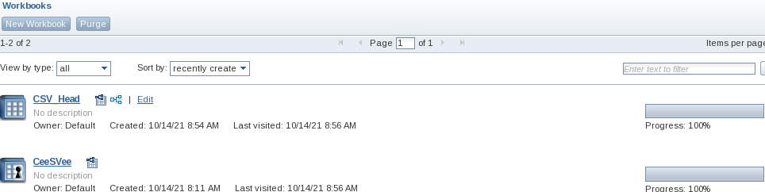

**B.2 Input and Output:**

**CeeSVee.csv**

| **truckid** | **driverid** | **event** | **latitude** | **longitude** | **city** | **state** | **velocity** | **event_ind** | **idling_ind** |
| --- | --- | --- | --- | --- | --- | --- | --- | --- | --- |
| A54 | A54 | normal | 38.440467 | -122.714431 | Santa Rosa | California | 17 | 0 | 0 |
| A20 | A20 | normal | 36.977173 | -121.899402 | Aptos | California | 27 | 0 | 0 |
| A40 | A40 | Over  speed | 37.957702 | -121.29078 | Stockton | California | 77 | 1 | 0 |
| A31 | A31 | normal | 39.409608 | -123.355566 | Willits | California | 22 | 0 | 0 |
| A71 | A71 | normal | 33.683947 | -117.794694 | Irvine | California | 43 | 0 | 0 |
| A50 | A50 | normal | 38.40765 | -122.947713 | Occidental | California | 0 | 0 | 1 |
| A51 | A51 | normal | 37.639097 | -120.996878 | Modesto | California | 0 | 0 | 1 |
| A19 | A19 | normal | 37.962146 | -122.345526 | San Pablo | California | 0 | 0 | 1 |

**CSV_Head.csv**

| **Field_Length** |
| --- |
| 65 |
| 60 |
| 65 |
| 62 |
| 61 |
| 63 |
| 61 |
| 63 |

**B.3 Observations and learning:**

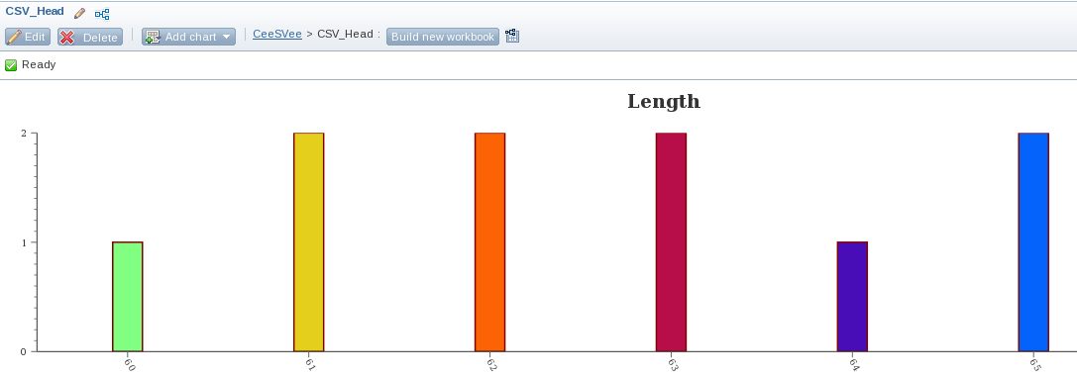

**B.4 Conclusion:**

Thus, able to not only explore Bigsheets but also gained valuable experience from it.

**B.5 Question of Curiosity**

1. How business data can be analyzed explain with suitable examples?

**Ans:**

Strategic Analyses -- Analyzing External and Internal Environments

A frequent complaint about strategic plans is that they are merely "to-do" lists of what to accomplish over the next few years. Or, others complain that strategic planning never seems to come in handy when the organization is faced with having to make a difficult, major decision. Or, other complain that strategic planning really doesn't help the organization face the future. These complaints arise because organizations fail to conduct a thorough strategic analysis as part of their strategic planning process. Instead, planners decide to plan only from what they know now. This makes the planning process much less strategic and a lot more guesswork. Strategic analysis is the heart of the strategic planning process and should not be ignored.

1. Taking a Wide Look Around the Outside of the Organization to Identify Opportunities and Threats. An external analysis usually includes looking at various trends, including political, economic, societal, technological and ecological. Also, consider the needs and wants of stakeholders -- do a stakeholder analysis.:
2. Looking Around Inside of Organization to Identify Strengths and Weaknesses. The following assessments might be useful in helping you to take a look around the inside of your organization -- to assess the quality of all of its operations:

* Organizational Assessments for For-profits.
* Organizational Assessments for Non-profit.
* People Problems Masquerading as Business Problems.